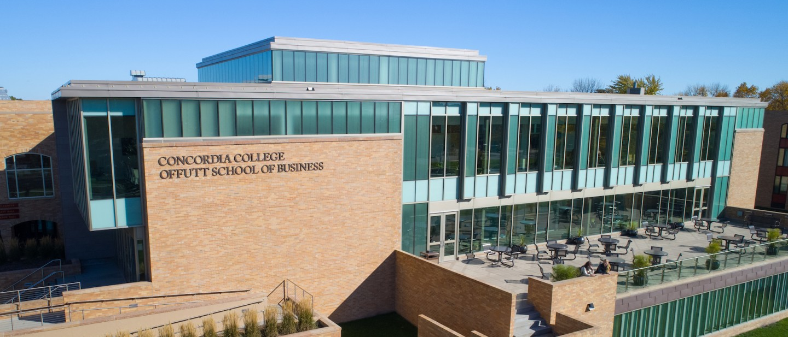

Project Plan

|  |
| --- |
| Zulip |

|  |  |
| --- | --- |
| Course | **CSC 340 – Principles of Software Engineering** |
|  | |
| Team Name | **OSEA** |
|  |  |
| Team Members | **Emily Davis** |
|  | **Shristi Chapagain** |
|  | **Amira Mohamed** |
|  | **Oriana Penaloza Ortega** |

|  |
| --- |
| Executive Summary |
| * Take zulip to the next level * Add way to filter on reaction emojis * Add way to set status * Make Zulip skinnable * Add location |

|  |
| --- |
| Timeline |

**Tuesday, December 14**

**Milestone 6**

Final  
Presentation

**Thursday, December 2**

**Milestone 5**

Requirements Engineering P2

**Thursday, November 11**

**Milestone 4**

Requirements Engineering P1

**Tuesday, September 28**

**Milestone 2**

Project  
Proposal

**Thursday, October 21**

**Milestone 3**

Project  
Pitch

**Tuesday, September 7**

**Milestone 1**

Group  
Contract

|  |  |  |
| --- | --- | --- |
| Milestone Summary | | |
| **Milestone 1** | **Group Contract** | Wednesday, September 29 |
| **Item** | **Description** | **Date Completed** |
| **Purpose** | **Create a final project team** | **September 7, 2021** |
| **Summary** | Self-organize into groups of 3-4 students for working together on the semester project.  All team members will need to complete the group contract and agree to its terms, holding each other accountable for contributing to the final project throughout the semester. |  |
| **Task M1A – Team Member Names** | List all team members with full (first and last) names on the group contract document |  |
| **Task M1B – Team Name** | Come up with a name for the group/team to be addressed as during presentations; list the name on the group contract document |  |
| **Task M1C – Weekly Meeting Time** | Block off an hour of time once per week when all team members could regularly meet as necessary throughout the semester; list the time in the group contract document |  |
| **Task M1D – Signatures** | Each team member signs the group contract document (this may be a digital signature or initials) |  |
| **Milestone 2** | **Project Proposal** |  |
| **Item** | **Description** | **Date Completed** |
| **Purpose** | **Determine final project topic** | **September 28, 2021** |
| **Summary** | As a group, choose a topic all team members want to work on; discuss potential ideas and come to a group consensus what your project will be and why it is important. |  |
| **Task M2A – Project Proposal Document** | Complete the project proposal document |  |
| **Task M2B – Presentation** | Present the project proposal to the class |  |
| **Task M2C – Planning Document** | Complete the executive summary section of the planning document, fill in the date each milestone task was completed in the milestone summary, and detail the additional milestone activities in the Milestone Summary section (insert new rows into the table). |  |
| **Milestone 3** | **Project Pitch** | **10/21/2021** |
| **Item** | **Description** | **Date Completed** |
| **Purpose** | **Present your project to the class** | **October 21, 2921** |
| **Summary** | Armed with your project proposal and design mockups, show the class what you plan to accomplish with your project. Think of the class as potential investors or contributors; why should they care about your project? |  |
| **Task M3A – Presentation** | Pitch the project to the class |  |
| **Task M3B – Planning Document** | Include screenshots of the project pitch presentation, fill in the date each milestone task was completed in the milestone summary, and detail the additional milestone activities in the Milestone Summary section (insert new rows into the table). |  |
| **Milestone 4** | **Requirements Engineering Phase 1** |  |
| **Item** | **Description** | **Date Completed** |
| **Purpose** | **Provide detailed estimates for major features using custom user stories and scenarios** | **November 11, 2021** |
| **Summary** | Identify project stakeholders, create detailed user stories, and write scenarios. |  |
| **Task M4A – Presentation** | Present your milestone to the class. |  |
| **Task M4B – Planning Document** | Include relevant screenshots, stakeholders, user stories, and scenarios, fill in the date each milestone task was completed in the milestone summary, and detail the additional milestone activities in the Milestone Summary section (insert new rows into the table). |  |
| **Milestone 5** | **Requirements Engineering Phase 2** |  |
| **Item** | **Description** | **Date Completed** |
| **Purpose** | **Determine functional and nonfunctional requirements** | **Dec 2, 2021** |
| **Summary** | Using the user stories and scenarios from the previous milestone, formalize the functional and nonfunctional requirements of each major feature. |  |
| **Task M5A – Presentation** | Present your milestone to the class. |  |
| **Task M5B – Planning Document** | Include relevant screenshots, functional requirements, nonfunctional requirements, and use cases, fill in the date each milestone task was completed in the milestone summary, and detail the additional milestone activities in the Milestone Summary section (insert new rows into the table). |  |
| **Milestone 6** | **Final Presentation** |  |
| **Item** | **Description** | **Date Completed** |
| **Purpose** | **Show your completed project to the class** | **Dec 14, 2021** |
| **Summary** | Share your hard work over the course of the semester with the class. |  |
| **Task M6A – Presentation** | Present your completed project to the class |  |
| **Task M6B – Planning Document** | Include screenshots of your final project deliverables and presentation, fill in the date each milestone task was completed in the milestone summary, and detail the additional milestone activities in the Milestone Summary section (insert new rows into the table). |  |

|  |  |
| --- | --- |
| Resource List | |
| **Resource Name** |  |
| **URL** | **Github.com/Zulip/Zulip** |
| **Date Accessed** | **9/25/2021** |
| **Notes** | URL to repo of project |
| **Resource Name** |  |
| **URL** |  |
| **Date Accessed** |  |
| **Notes** |  |
| **Resource Name** |  |
| **URL** |  |
| **Date Accessed** |  |
| **Notes** |  |
| **Resource Name** |  |
| **URL** |  |
| **Date Accessed** |  |
| **Notes** |  |
| **Resource Name** |  |
| **URL** |  |
| **Date Accessed** |  |
| **Notes** |  |
| **Resource Name** |  |
| **URL** |  |
| **Date Accessed** |  |
| **Notes** |  |

**Milestone-3 Project Pitch**

**Estimated Timeline:**

**Gantt Chart:**

**Milestone-5 Requirements Engineering**

**Page Customization: Functional Requirements**

1. The system must allow users to select the setting menu
2. The system must allow users to choose color scheme for the chat
3. The system must allow administrative users to review the modifications
4. The system must allow users to see the new screen

**Page Customization: Non-Functional Requirements**

1. The system shall prompt users to page customization menu
2. The system shall update the selected color scheme in 12 seconds
3. The system shall notify the chat admin to authorize the new change
4. The system shall generate a new chat message screen for the users

**Page Customization: Use Case Diagram**

**User Status: Functional Requirements**

1. There should be an option to change the user status
2. Profile pictures should have a small space to show their user status
3. User status set by A should match what other people see on A’s profile
4. If user status is set for some time, the system should show the status as available after that time

**User Status: Non-Functional Requirements**

1. User status set by A should be seen immediately in other’s screen
2. User status set by a user should be accurate to what others see
3. Features to change the user status should be usable when clicking the profile picture

**User Status: Use Case Diagram**

**Activity Center: Functional Requirements**

1. The system must allow users to create their own emotes
2. The system must have a screen (activity center) for users to see emotes to their posts
3. The system must have an option to enable emote notifications

**Activity Center: Non-Functional Requirements**

1. The system shall be easy to navigate
2. The system shall display emotes with enough resolution to tell what they are
3. The system shall load images quickly

**

**Location: Functional Requirements**

1. The system allows users to share their location with others.
2. The system shares the current location of the user.
3. The location will be sent by pressing a button next to the name of the user which will receive the location.

**Location: Non-Functional Requirements**

1. The system has to be easy to access.
2. The system has to be easy to understand.
3. The system will have a very detailed image of the location area.

